Power electronics Project Part C

Prepared by : Tadala Miutmbili

Due date : 22 may 2026

Question 1 – Theoretical
- 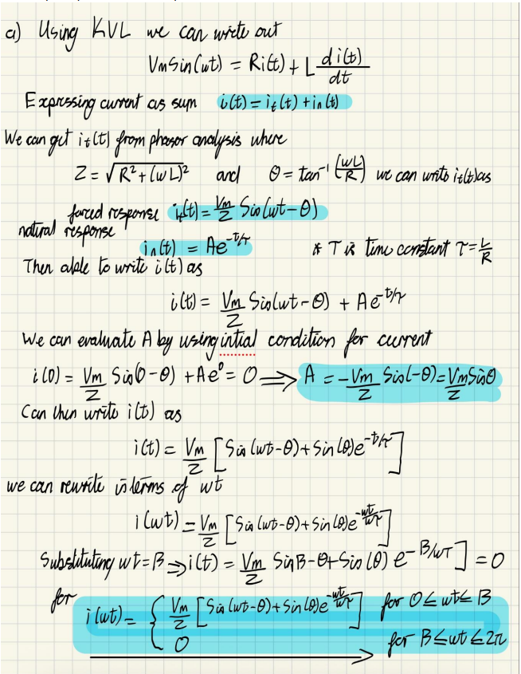
Figure 1derivation for general expression for current in half wave rectifier

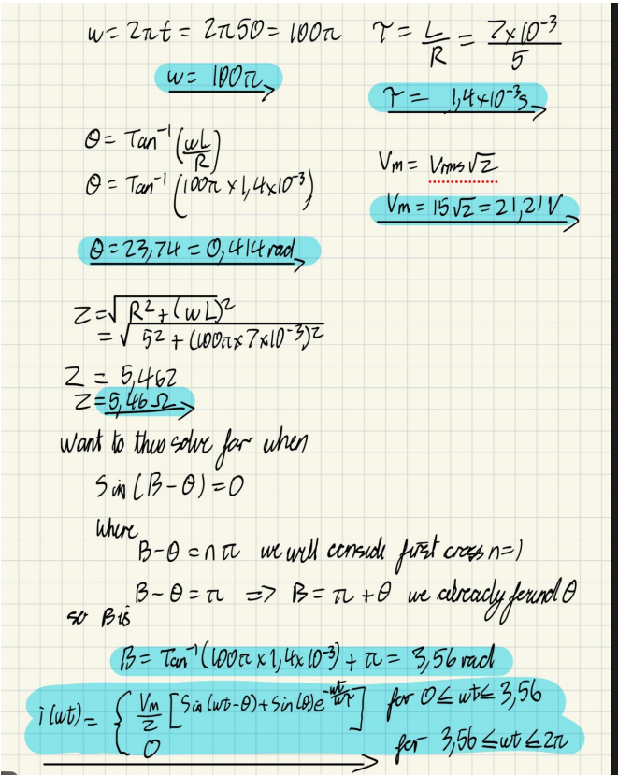
The final expression can be written as 3.56rad = 203.74
$$i\left(ωt\right)= \frac{21.21}{5.46}\left[\sin\left(ωt-0.414\right)+ \sin\left(0.414\right)e^{-\frac{ωt}{0.44}}\right] for 0 ≤ ωt ≤3.56$$
$$0 for 3.56 ≤ωt≤2π$$

b. For half wave rectifier we would define current as follows
$$I_{0}= \frac{1}{2π}\int_{0}^{β}{i\left(ωt\right)d(ω)}$$
$$I_{0}= \frac{1}{2π}\int_{0}^{3.56}{ \frac{21.21}{5.46}\left[\sin\left(ωt-0.414\right)+ \sin\left(0.414\right)e^{-\frac{ωt}{0.44}}\right]d(ωt) }$$
$$I_{0}=1.29A$$
c. We can then calculate RMS current as follows
$$I_{rms}= \sqrt{\frac{1}{2π}\int_{0}^{β}{i^{2}\left(ωt\right)d(ω)}}$$
$$I_{rms}= \sqrt{\frac{1}{2π}\int_{0}^{3.56}{{ \left\{\frac{21.21}{5.46}\left[\sin\left(ωt-0.414\right)+ \sin\left(0.414\right)e^{-\frac{ωt}{0.44}}\right]d(ωt)\right\} }^{2}d(ωt)}}$$
$$I_{rms}=1.98A$$
d. The power absorbed by the RL load is
$$P= I_{rms}^{2}R$$
$$P= {1.98}^{2}×5=19.6W$$
e. The power factor is calculated as follows
$$PF= \frac{P}{V_{rms}I_{rms}}$$
$$PF= \frac{19.6}{15×1.98 }=0.66 lagging$$

Question 2 – Simulation in MATLAB
- For AC voltage sources with a peak of approximately 21.21 from the 15V RMS and frequency of 50Hz. I attain the following waveform
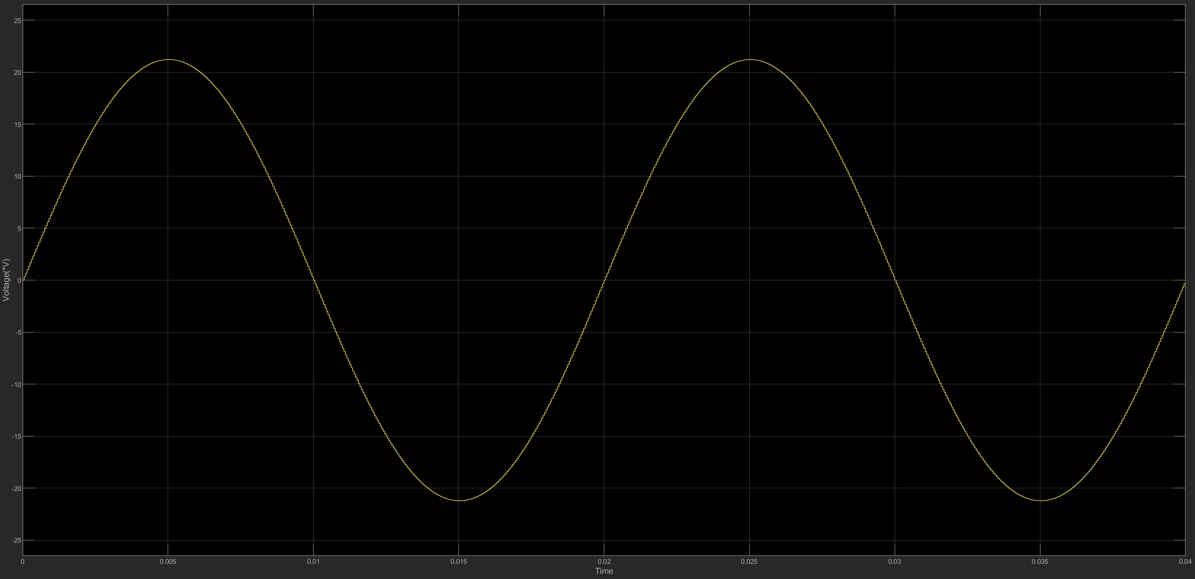
Figure 2 Source voltage for 2 cycles

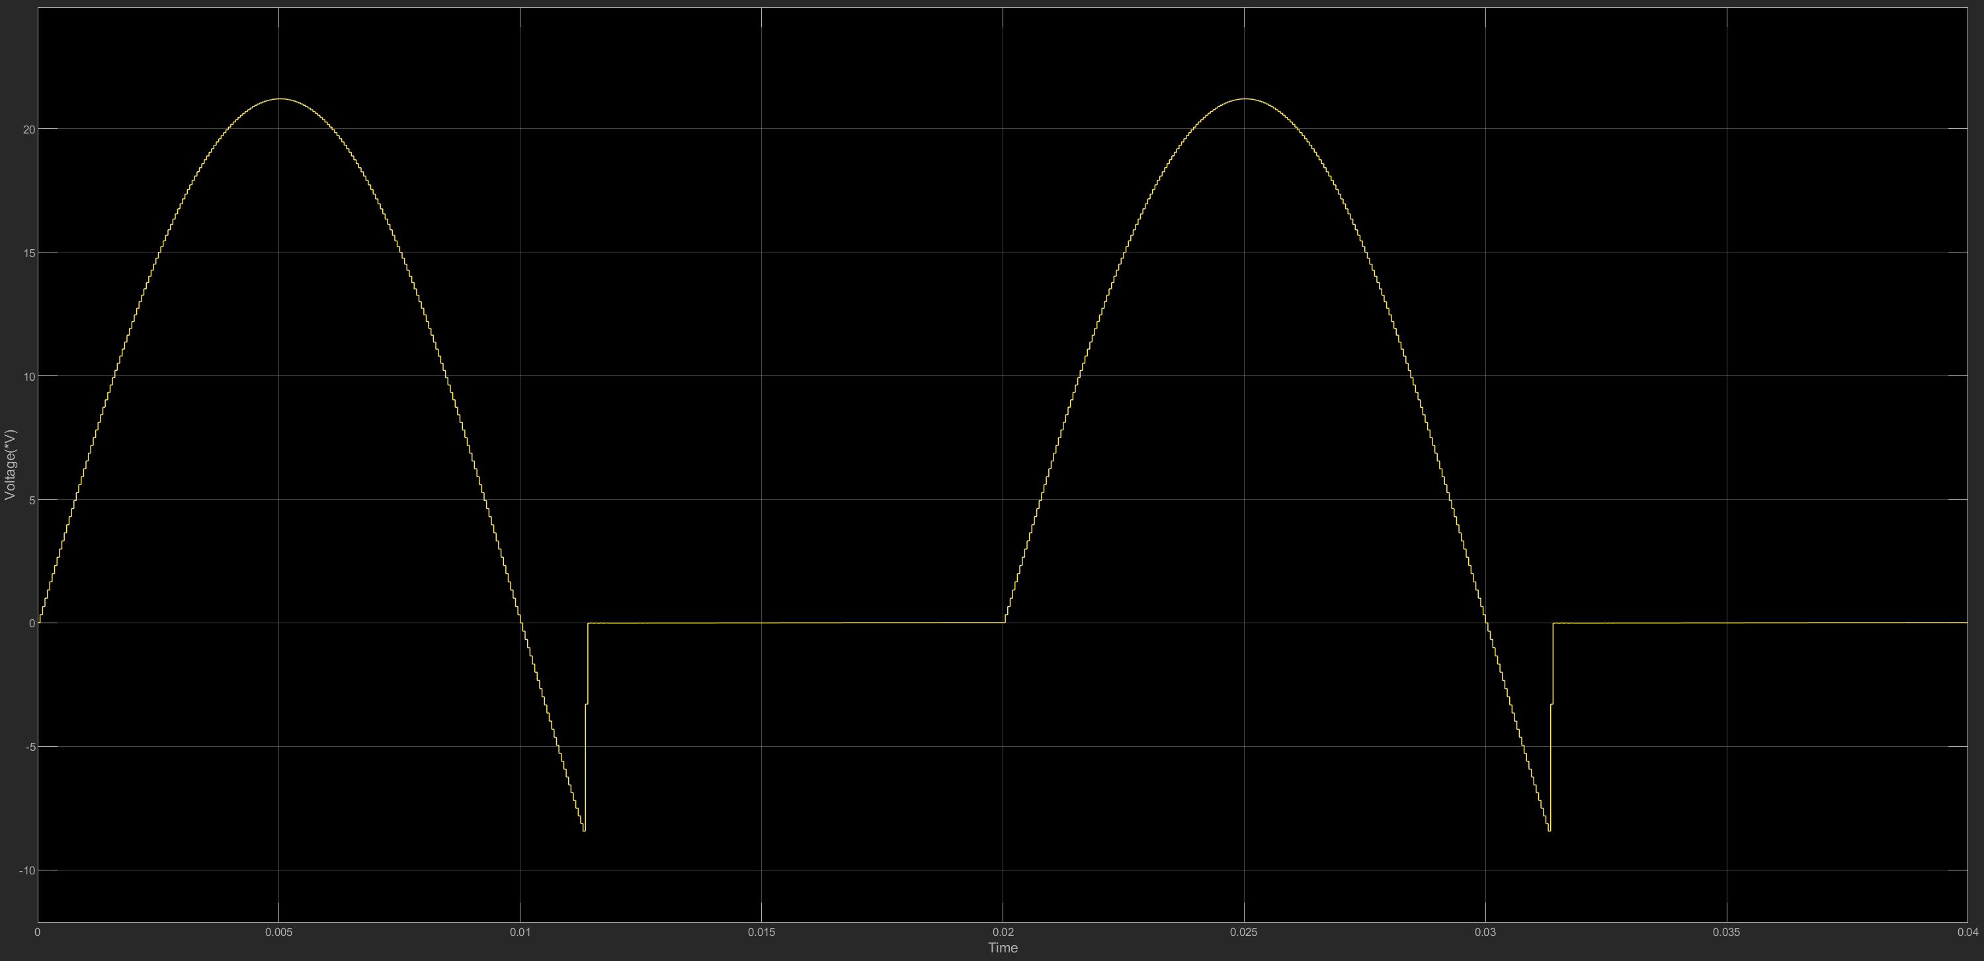
Figure 3 Load voltage

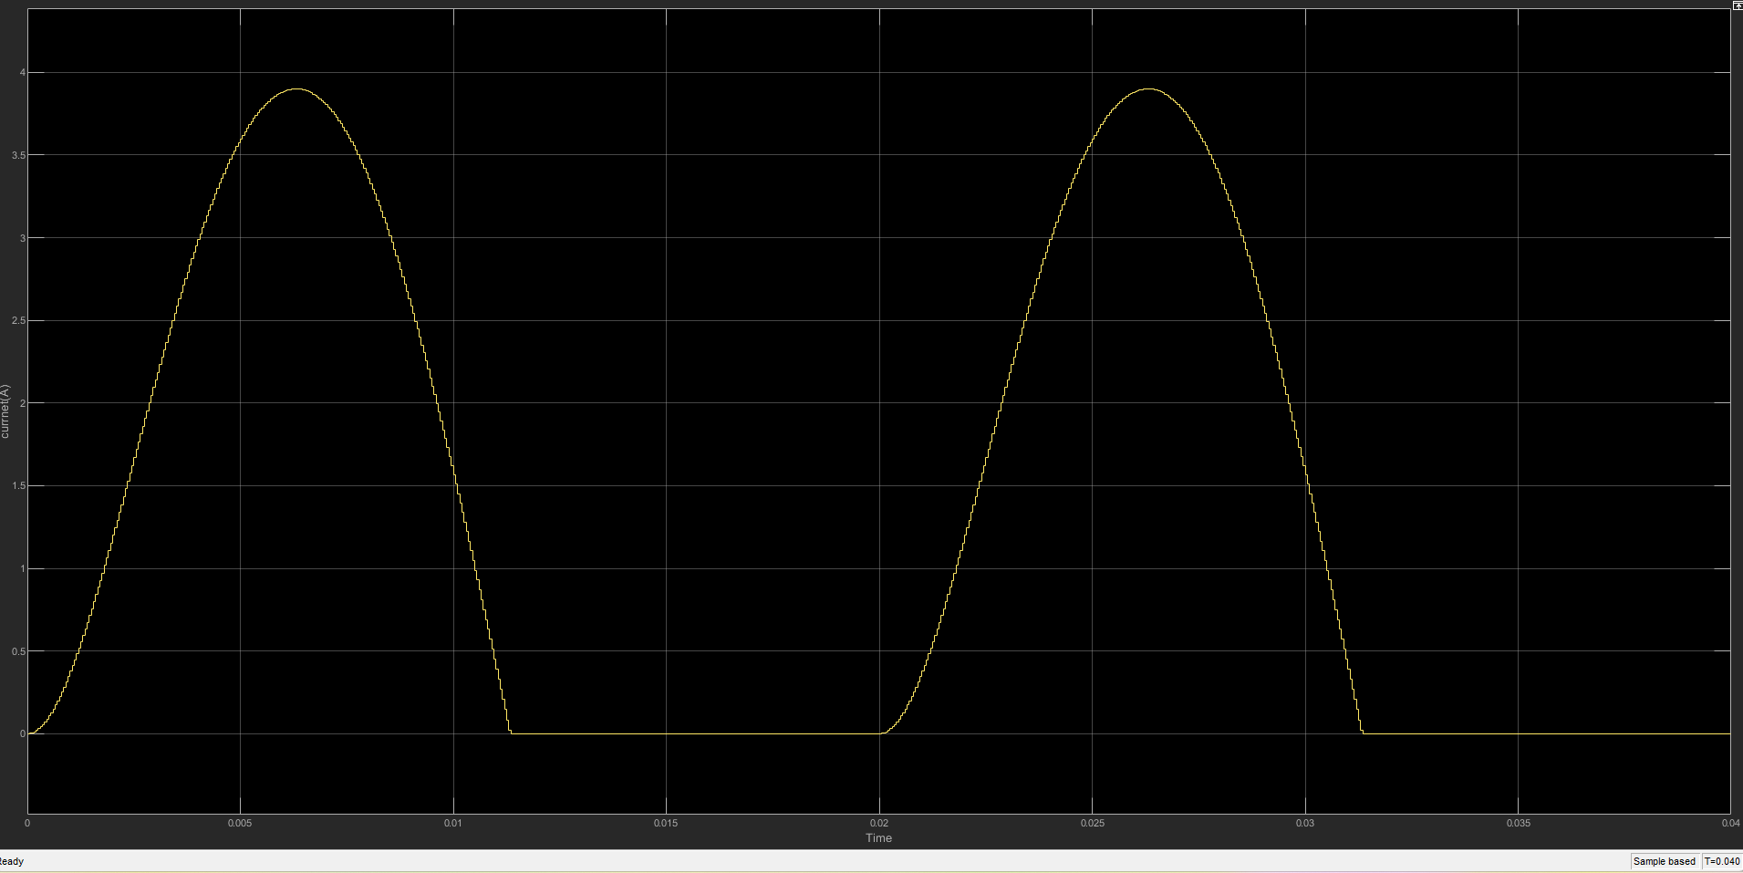
Figure 4 load current

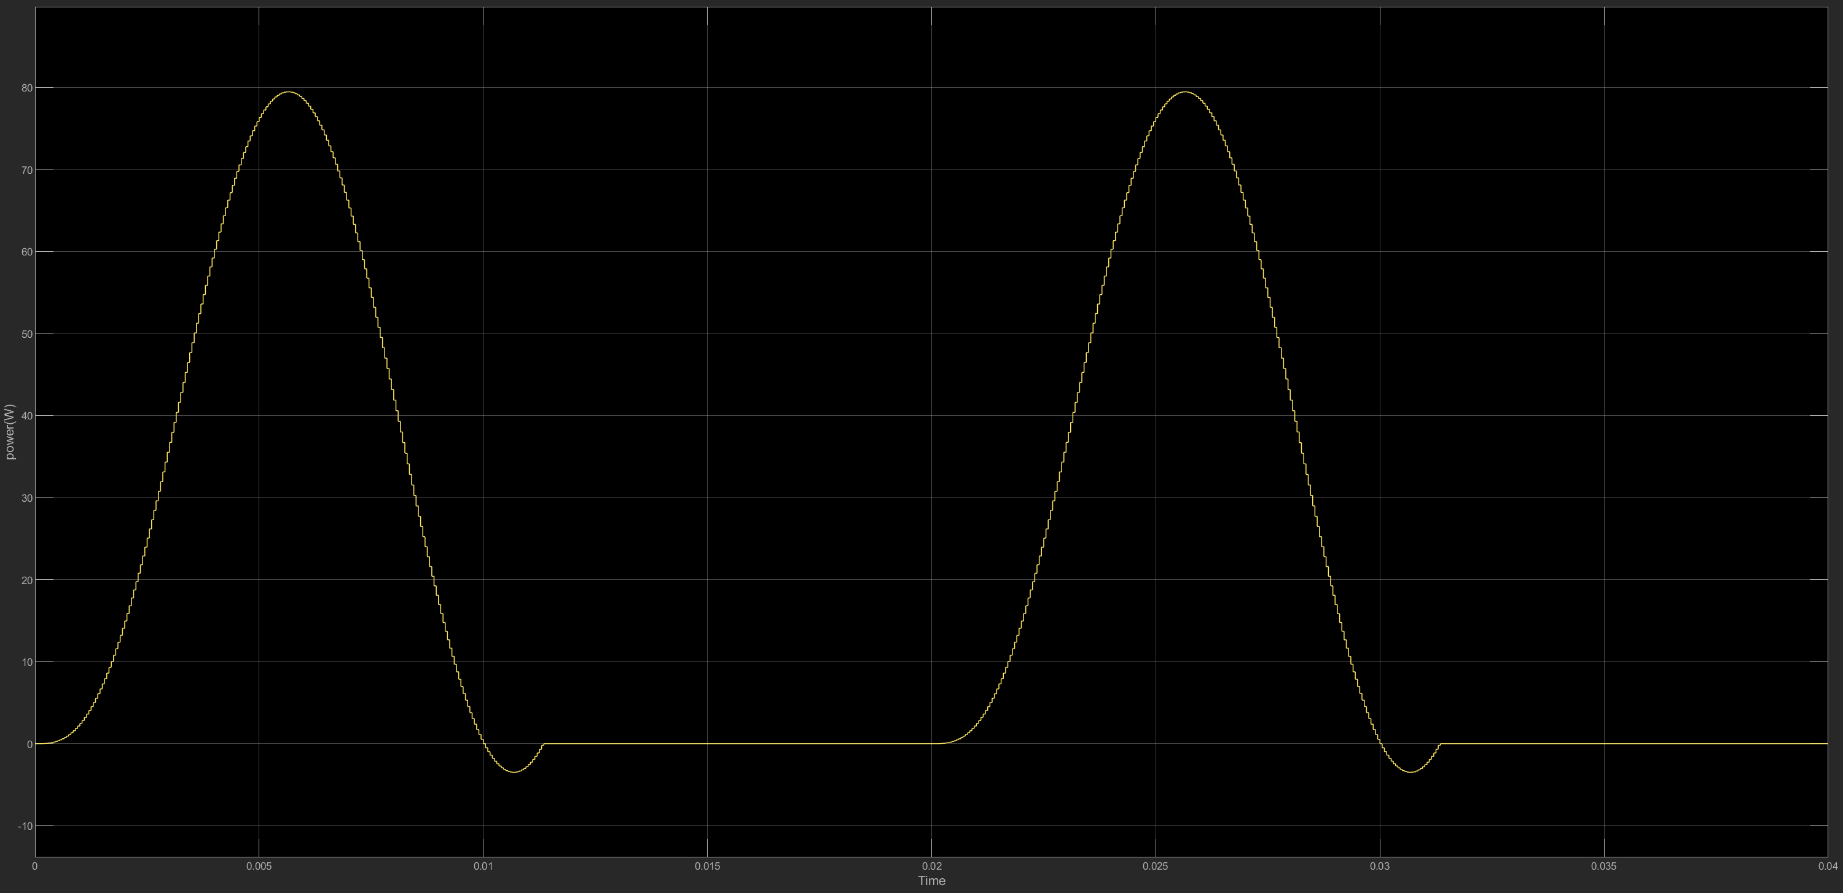
Figure 5 Instantaneous output power

- 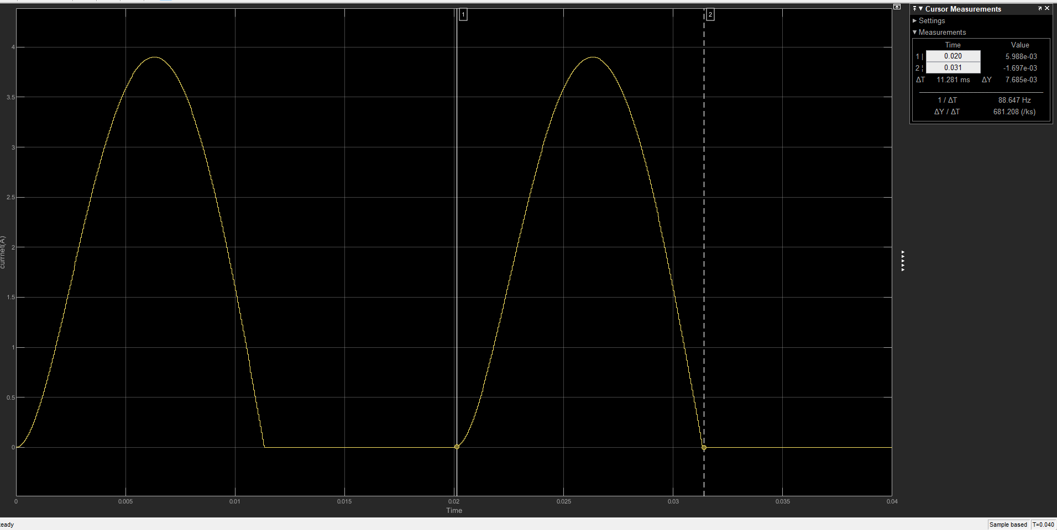
Figure 6 :Current waveform measurement for extinction angle
$$β= \frac{11}{20}×360=198 degree≈3.46 rad$$
We see that the extinction angle is lower than expected meaning the diode stops earlier than expected and so the energy is the inductor is dissipated faster causing load current to decay sooner
b.
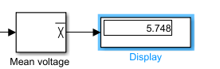
Figure 7 average voltage
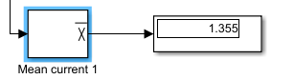
Figure 8 Average current
have that the measured value of the average current is 1.355A which is very close to the calculated 1.29A. which can be accounted for by consider that in most calculations we assume ideal passive components while Simulink may have parasitic resistances and simulate more like real world condition.

c.
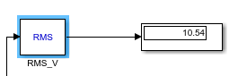
Figure 9 RMS load voltage
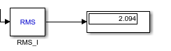
Figure 10 RMS current
The measured RMS values were 10.54V and 2.094A while the calculated values were 1.98A for RMS current which is very close to the measured value. Again, which can be accounted for the assumption of ideal components in calculation while as Simulink’s acts to be more realistic.
d.
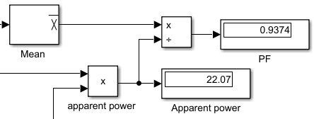
even with a simulation drop of 0V n=value swill still not match. The theoretical formulae make us of continuous calculus however in Simulink new are sampling at discrete intervals giving a sort of rounding effect but the PF value is still quite large of 0.9374. the displacement PF of the load itself is 0.915 which the measured PF is close to.

Harmonic | Magnitude | Phase
0 | 6.46 | 90
1 | 10.78 | 2.58
2 | 5.00 | -94.8
3 | 0.5657 | 40.23
4 | 1.237 | -115.4
5 | 0.5217 | 6.594
- This is due to stored energy in the inductive aspect of the circuit as the AC signal goes to zero the inductor releases its stored energy this causes D1 to conduct briefly even though the input is technically negative. This induced voltage keeps the diode forward biased forcing current to flow
- 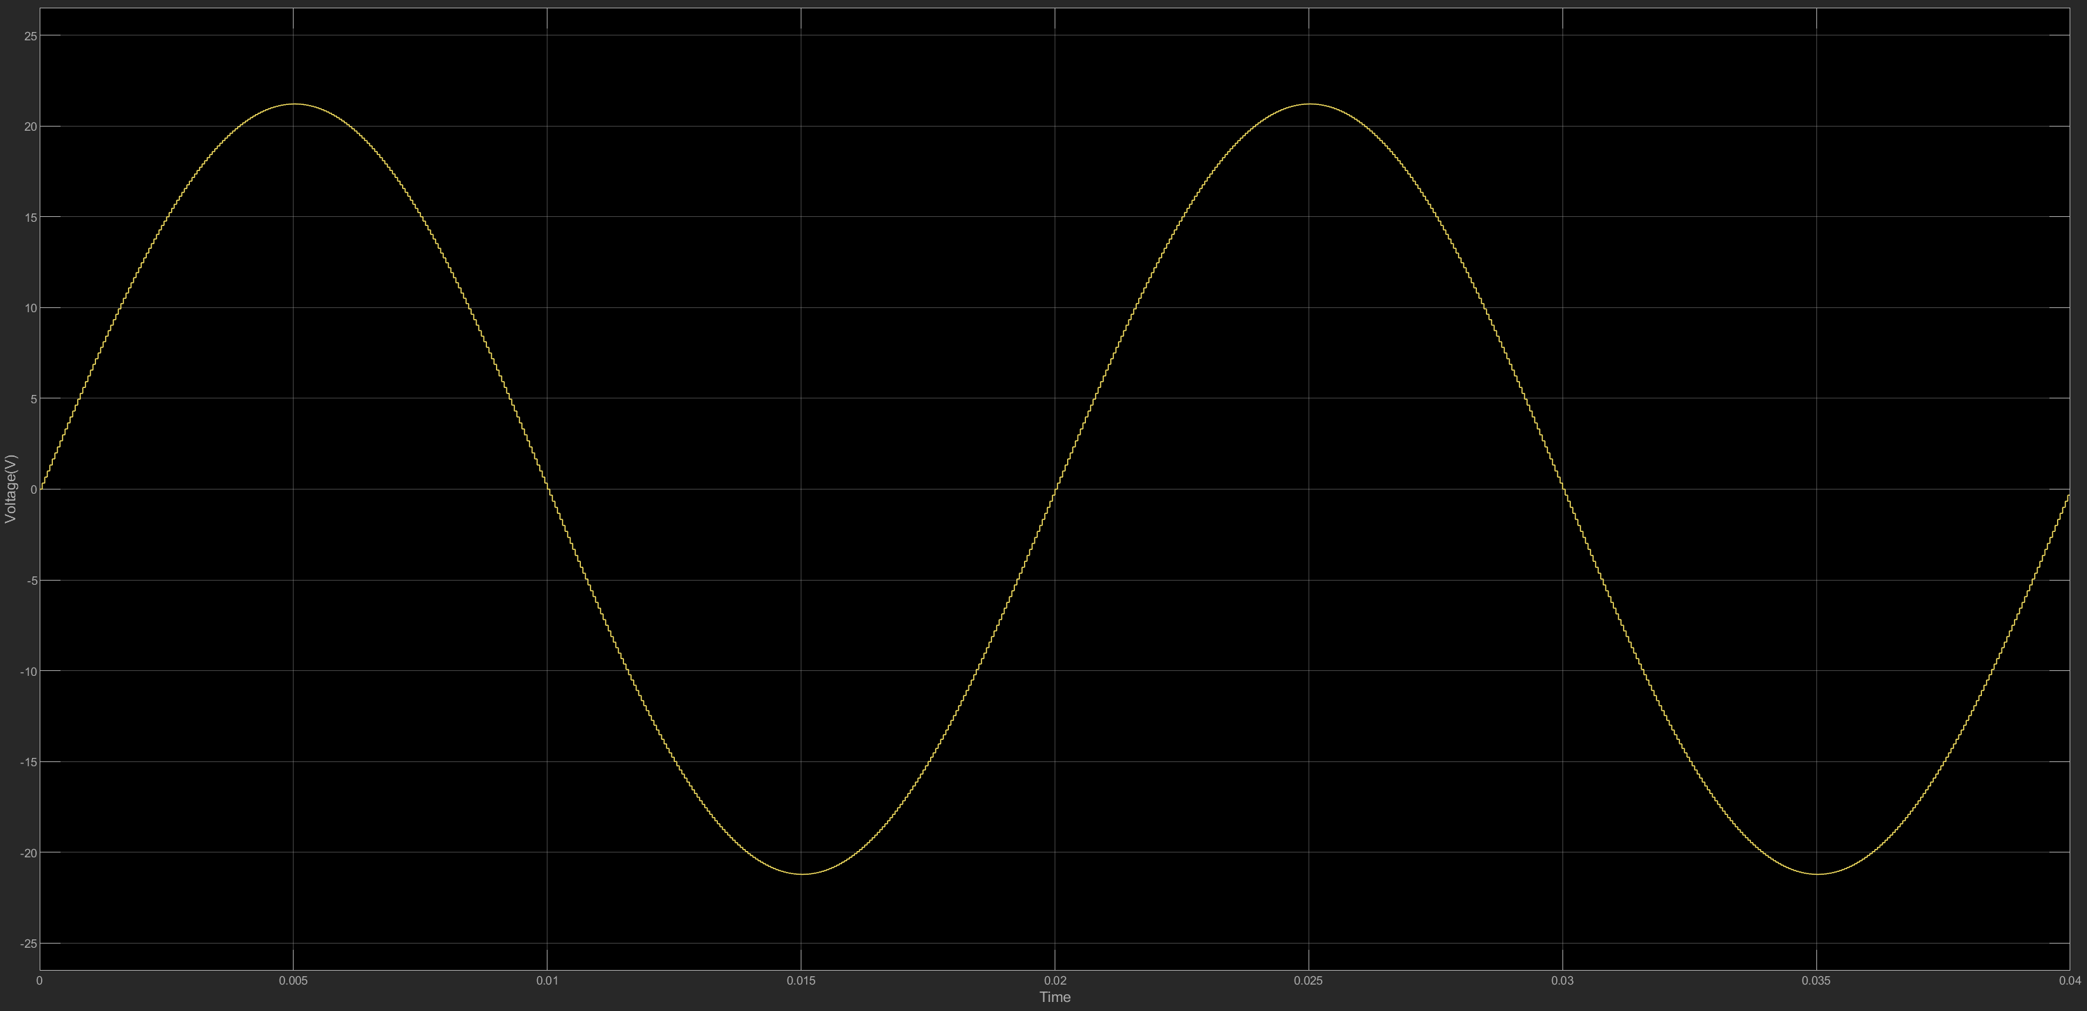
Figure 11 source voltage after adding free wheeling diode
As expected even with the addition of the freewheeling diode the voltage source remains unchanged.
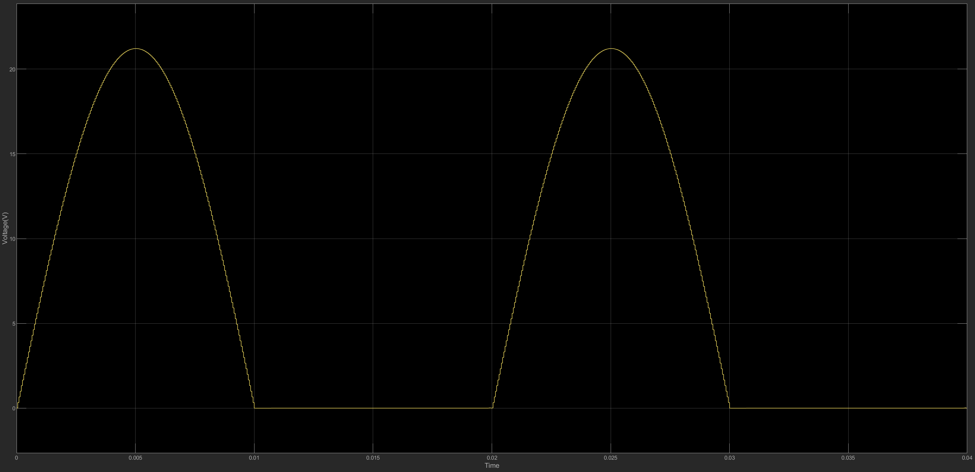
Figure 12 Load voltage with wheeling diode added across RL
We see the load voltage is now purely made up of the positive half cycle.
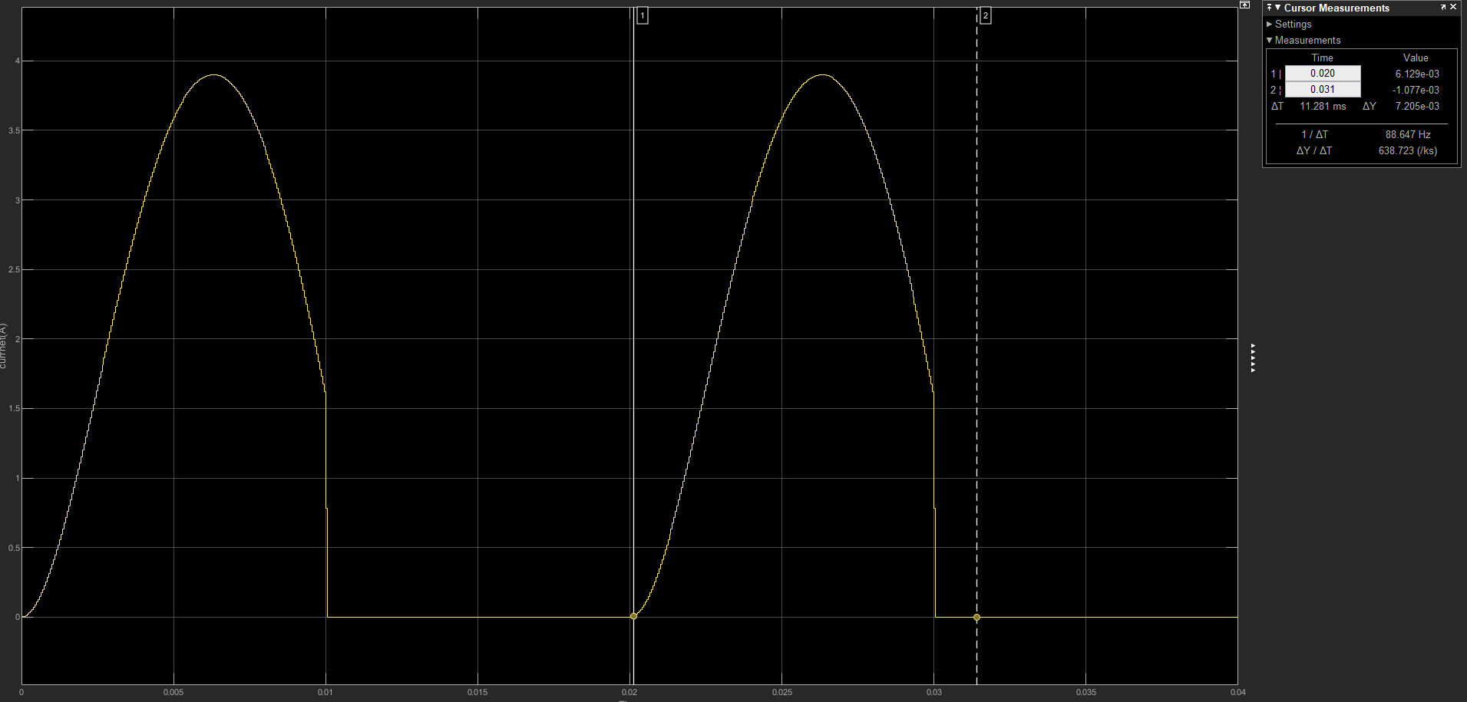
Figure 13 Load current after adding the wheeling diode across RL with cursor measurements
We see the load current is clipped.
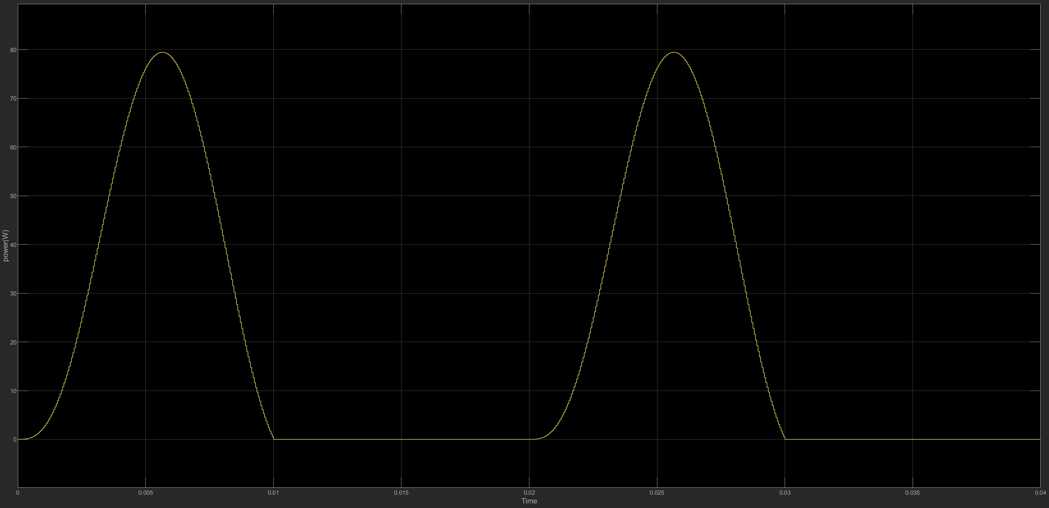
See that the voltage source waveform remains the same however now the load current and voltage have a smoother waveform rather than abruptly going to zero and also remain positive. And therefore, now the instantaneous output is always positive as well. These changes improve energy utilization and reduce voltage spikes across the load

- Would need to store energy during the conducting half of the Ac cycle and then release it during the non-conducting half so as to keep the current flowing through the load without interruption. We can also opt to make the load time current big enough

Question 3 – Experimental results

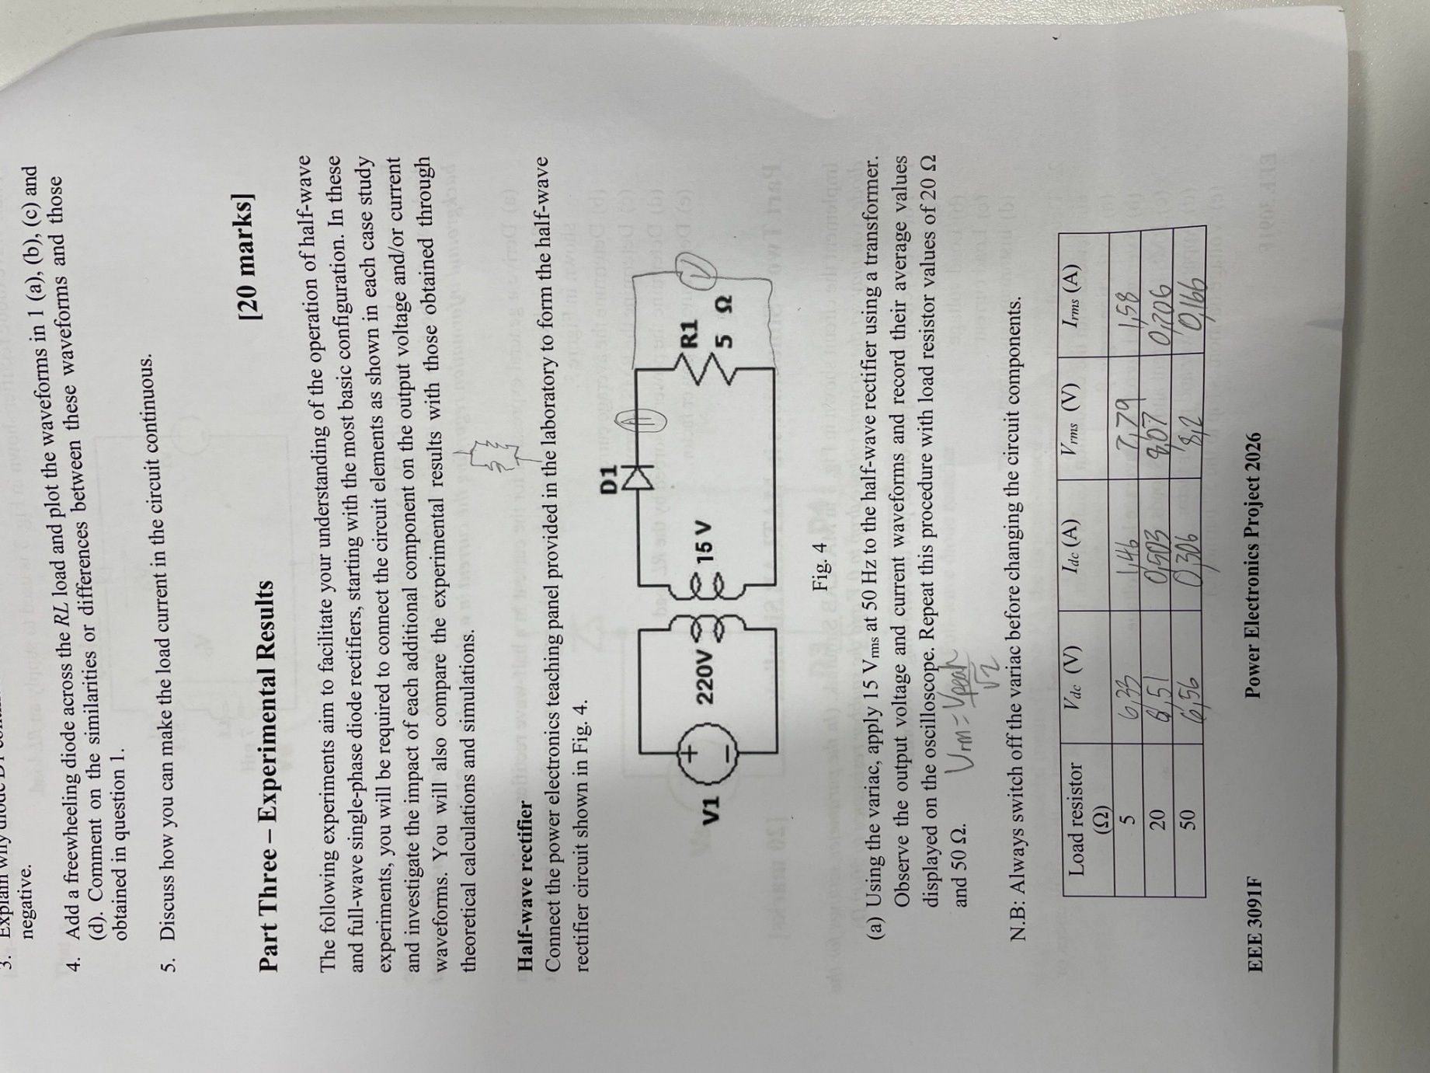
Figure 14 Half wave rectifier results across various loads
The calculated value for VDC closely resemble those obtained during the practical session. However, there was still some discrepancies that were noticed in the values for the RM voltage current and IDC. This can be due to the fact that in calculation we assume ideal values for components such as resistance or drops across diodes etc and are unable to account for tolerance in components values and inaccuracy in machine readings.

- 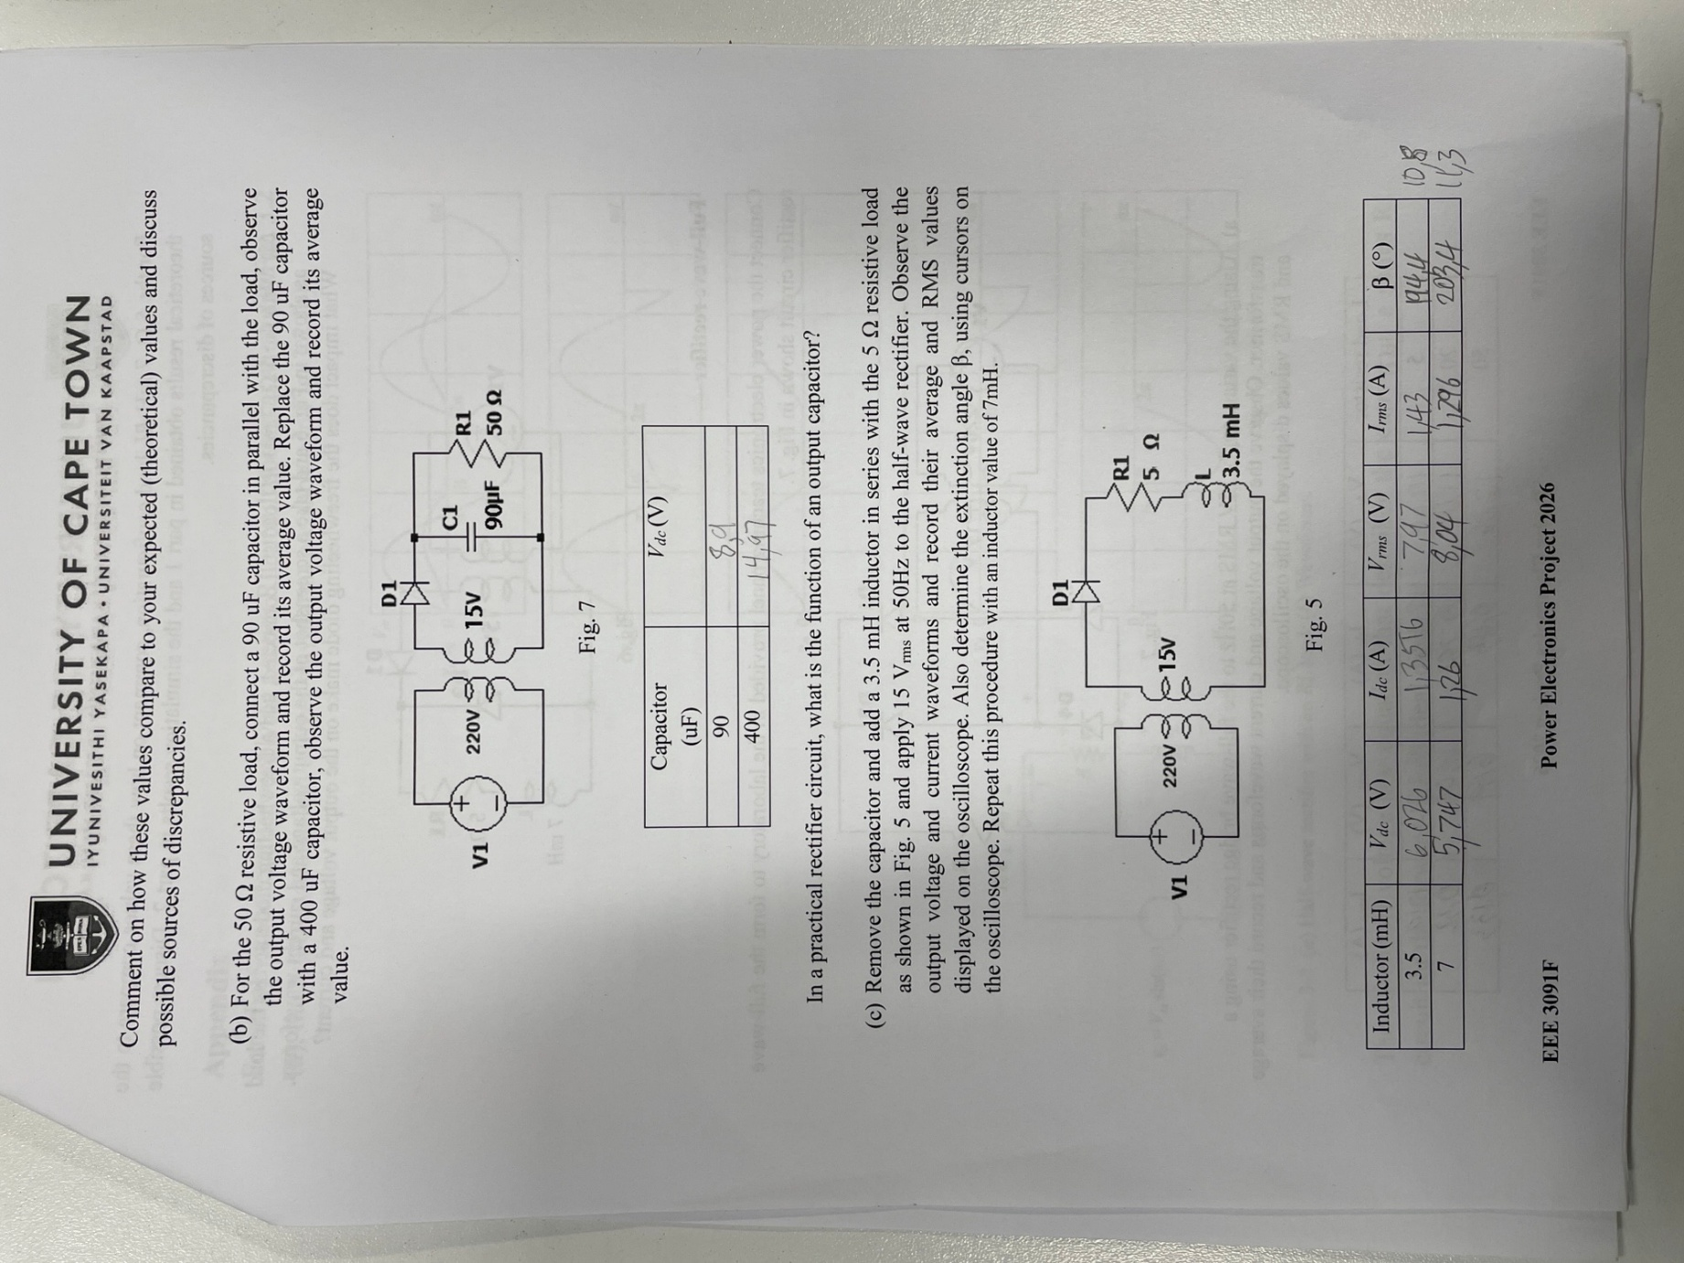
Figure 15 half wave with an added capacitor in parallel
Capacitor can serve to function as a sort of filter and give a smoother DC voltage]
- 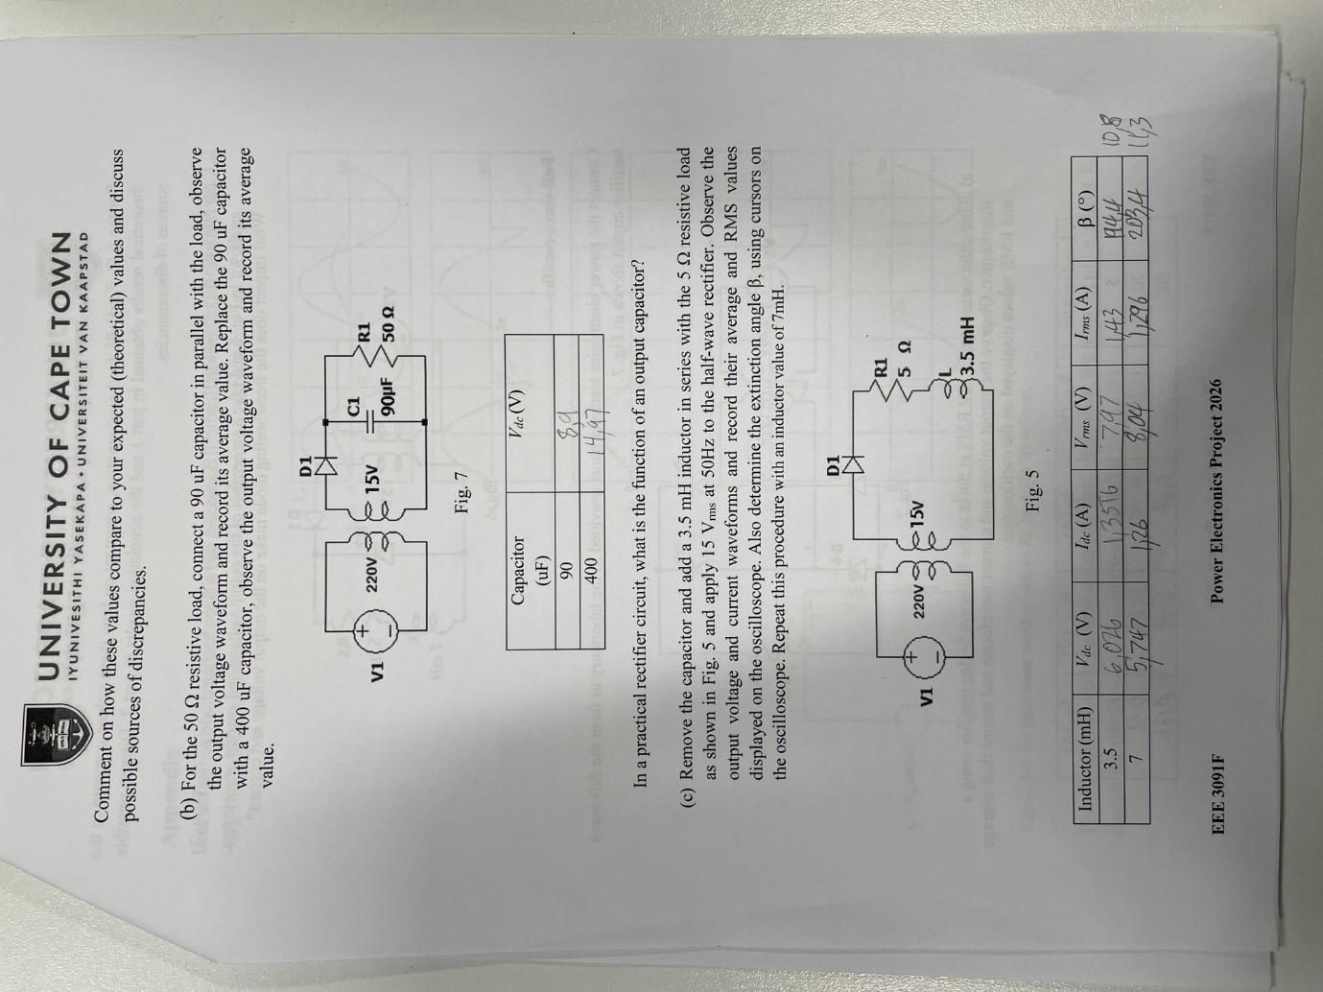
Figure 16 remove the capacitor and add inductor instead
Although the values found in the lab closely resemble those seen in the calculations done for part one there is still however noticeable discrepancies in the values which can most likely be attribute to the fact that in calculation, we assume ideal condition for components such as the inductor and resistor and as well for the source. While in actuality that is not the case and there are slight differences fluctuations present when measurement and selecting components which can account for the difference in values seen in the lab and calculation. Also due to the fact that we may not use the exact same point in calculation as we did in the lab and they can be off by small amount.
- 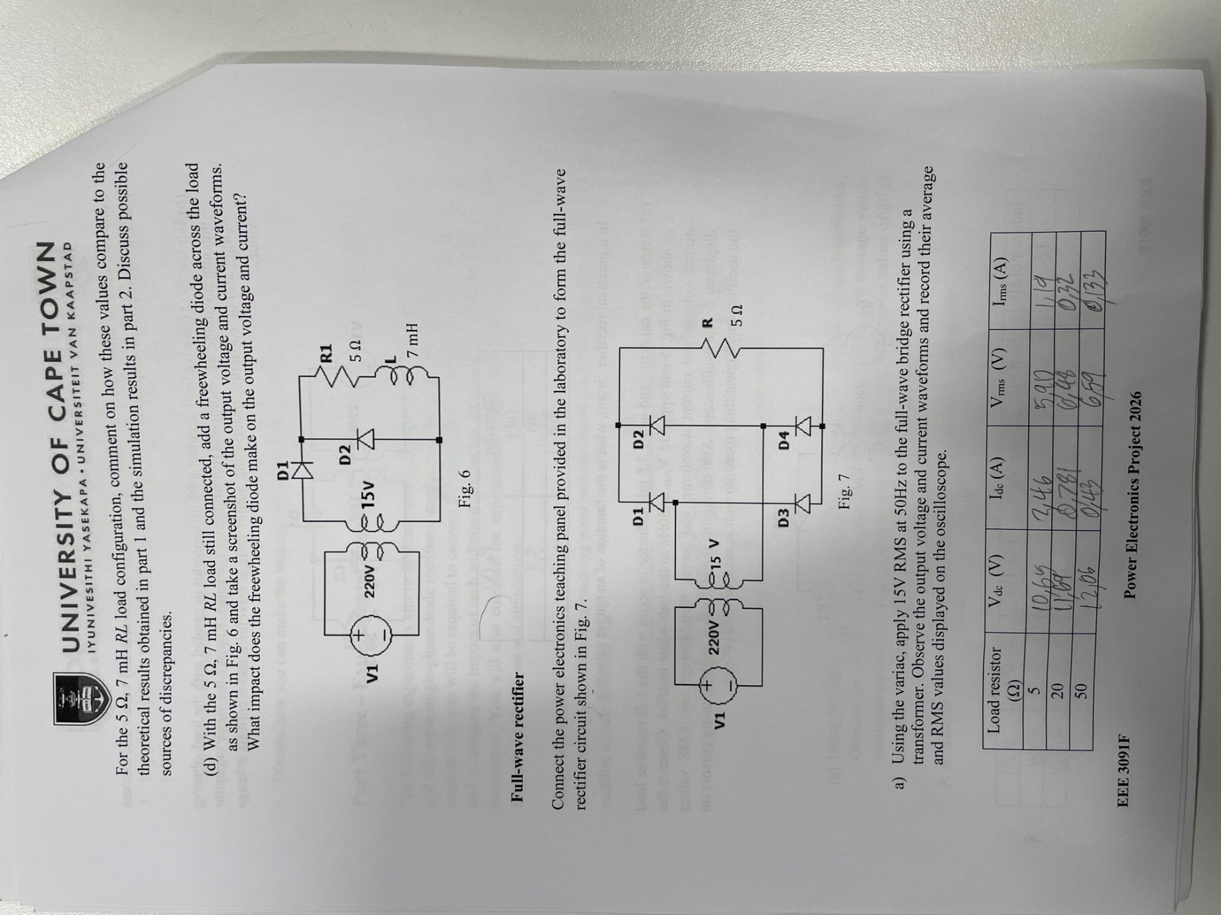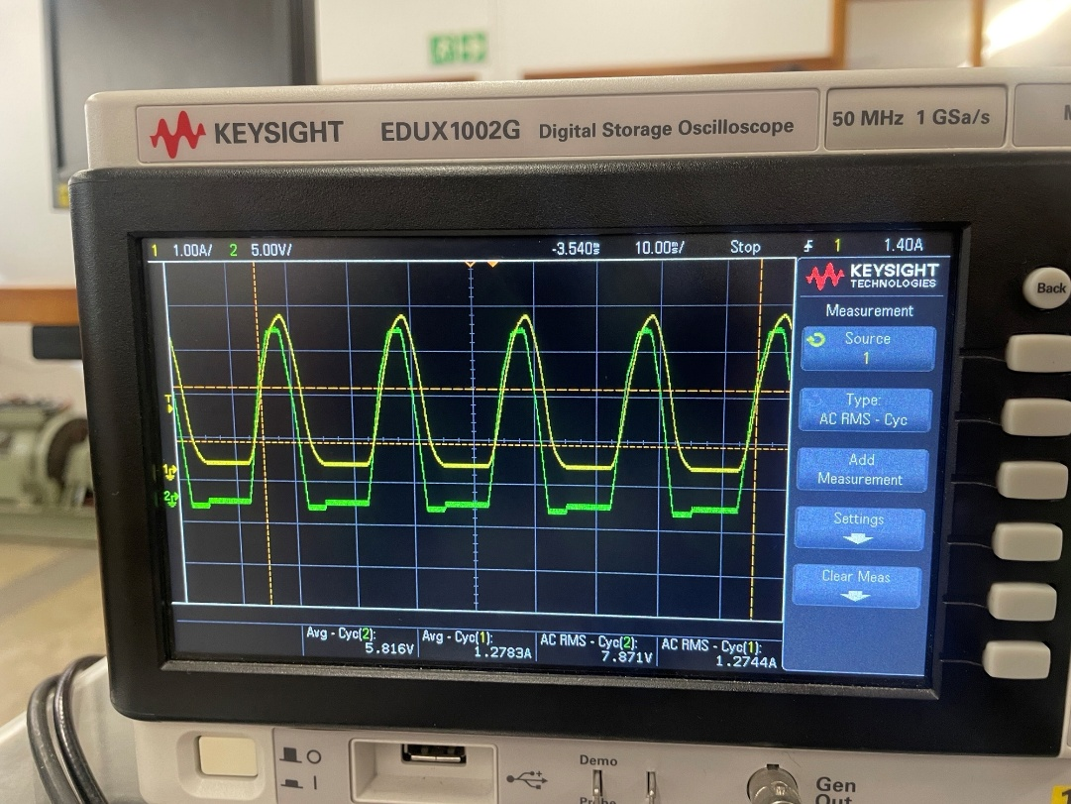
Figure 17 Screenshot of output voltage and currents waveforms
With the addition of the freewheeling diode, we are able to see that the diode has an impact on the waveforms for both the load voltage and current and acts to removes the dip as previously seen in the previous waveforms for voltage and current and produces a smoother curve as well as no spike in values.
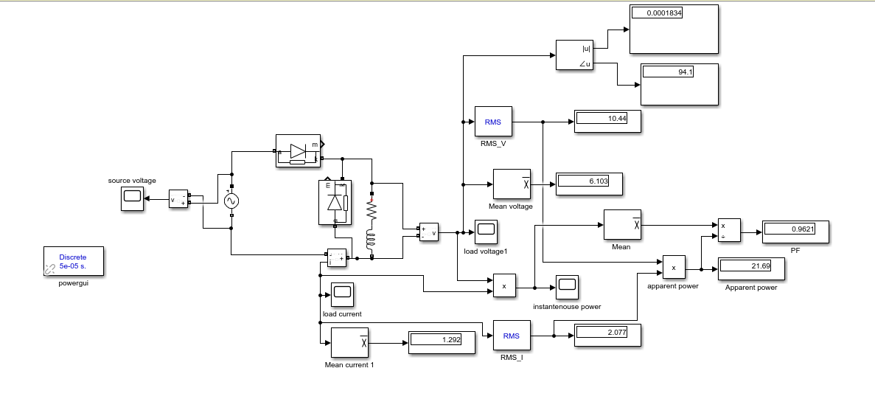
Figure 18 MATLAB circuit
FULL WAVE RECTIFIER



